1, Make sure docker image and service is available:



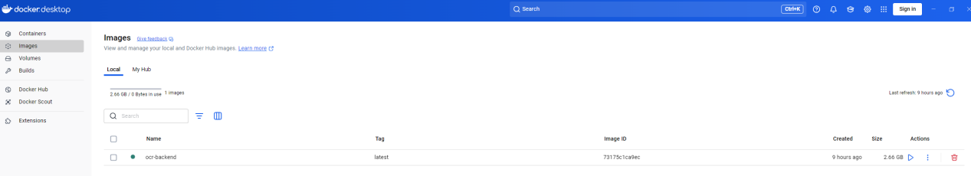

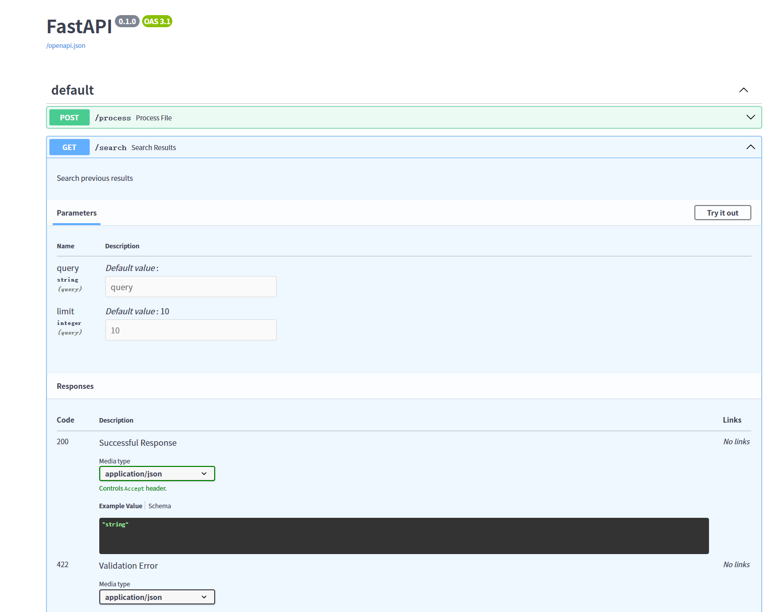

2, As there isn’t front-end, use commands instead:

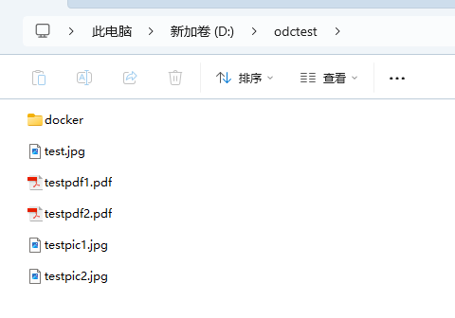

Process image file:

curl -X POST -F "file=@testpic1.jpg" http://localhost:8000/process



Response message after OCR processed(after formatted):

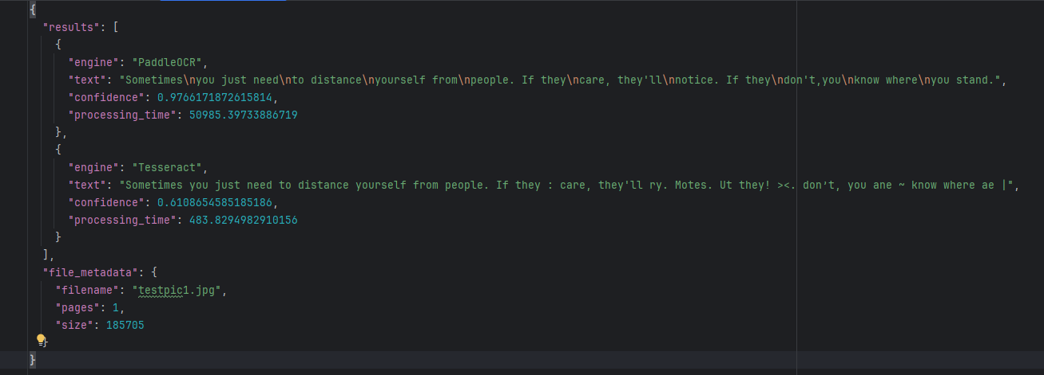

Process PDF file:

curl -X POST -F "file=@testpdf1.pdf" <http://localhost:8000/process>



Response message after OCR processed(after formatted):

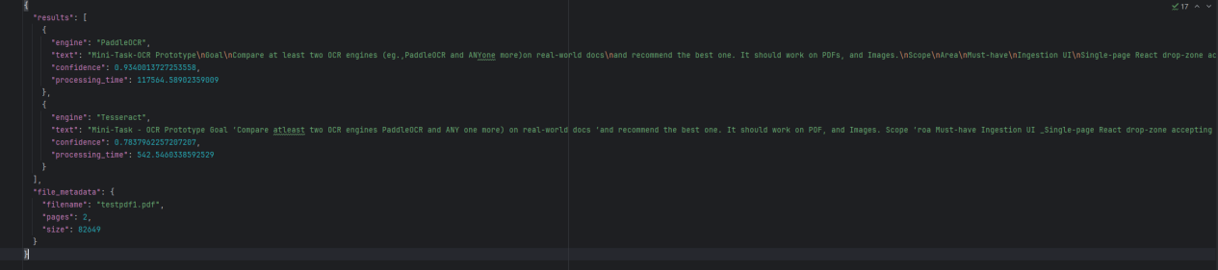

3, We can check process history by GET request:

